16. fhediagram yerow shows a wooden sod with a magnet P and iron ball Q hanging from  
a rope. |

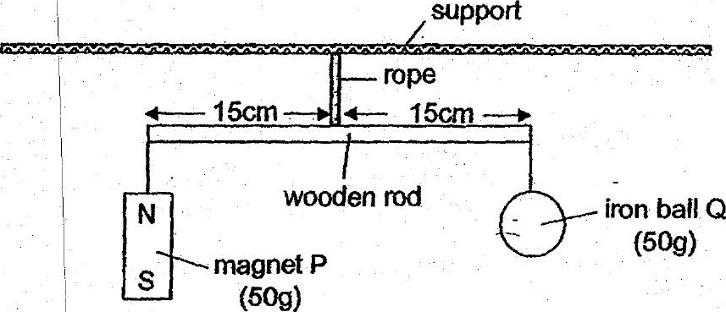

Waiech one or ine following statements Is faise’?

wooden rod. wil tif towards magnet P. .--

wooden rod wil fit towards magnetP.

|  
(3) | When the south pole of another magnet is placed under magnet P, the

wooden red will tit towards iron balf OQ.

wooden roa ‘will tit towards Iron Dall Q.