\  
20. Four masses were tied to four ropes made from different materiafs J, K, L and M as  
shown in the diagram below. The ropes were all of similar thickness. When the masses  
were lifted by the ropes, ropes K and L broke.

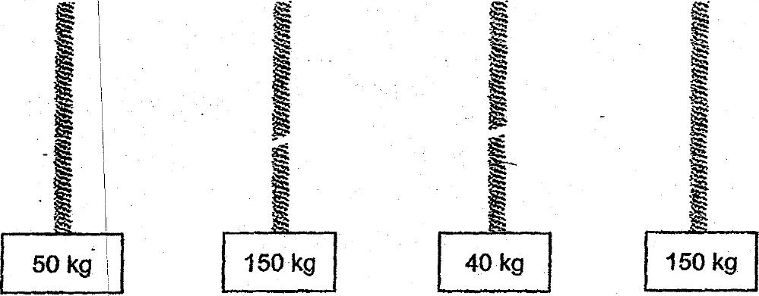

Which of the following statements is definitely true?

A Material L is the weakest.

B Material Mis the strongest.  
- Matérial J is stronger than material. L.

_-D Material K is weaker than material M.







