

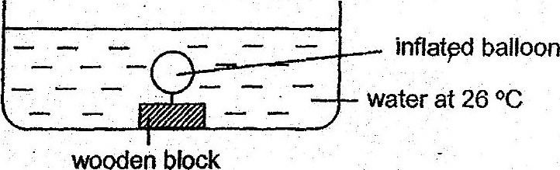

Which one of the following shows the most likely observation and  
corresponding explanation when. the water in the container was heated to  
65 °C? : .

