



CHIU ST NICHOLAS GIRLS’ SCHOOL

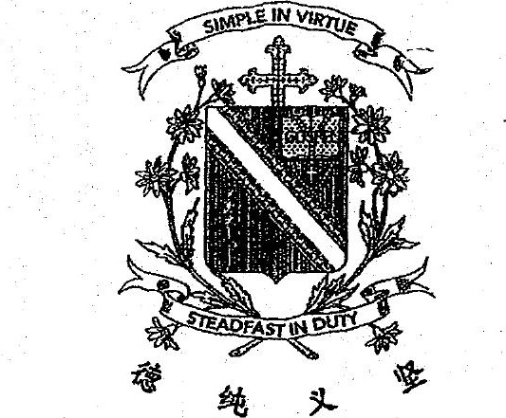





SCIENCE









Do not open this booklet until you are told to do.so.  
Foltow all instructions carefully.  
Answer all questions. .

this Dooklet consists of 27 printed pages.