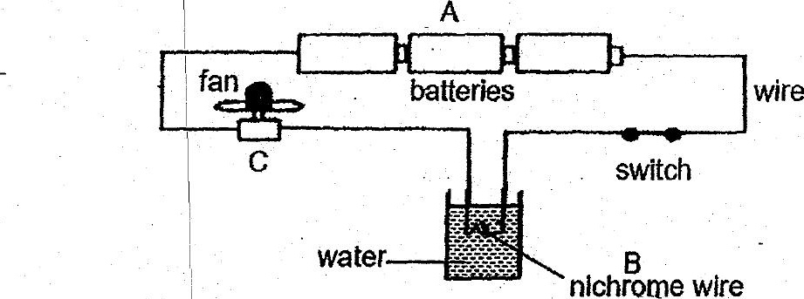

When the switch was closed, the fan started moving and the water in the  
container was slowly heated up.



