27. Tne diagram below shows a man throwing a ball.

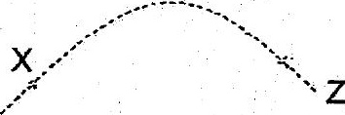

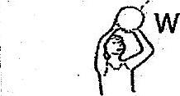

Which of the following statements is / are true?



8S At point X, bail slows down because of gravity.









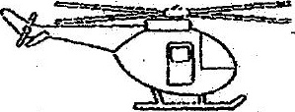

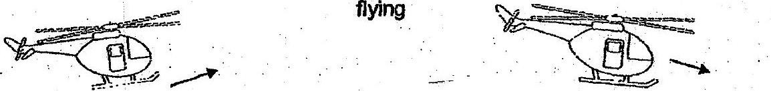



At which stage(s) does gravity act on the helicopter?



(2) Taking off and flying only

(3) Taking off and landing only



~~ End of Booklet A -~