



CHI ST NICHOLAS GIRLS’ SCHOOL

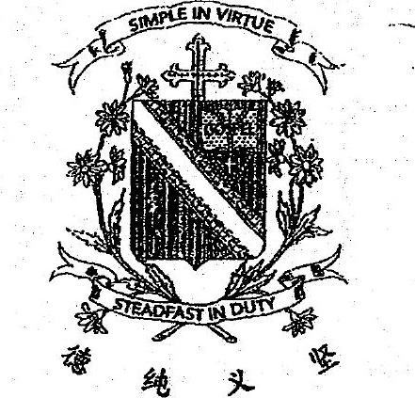



Preliminary Examination  
| SCIENCE





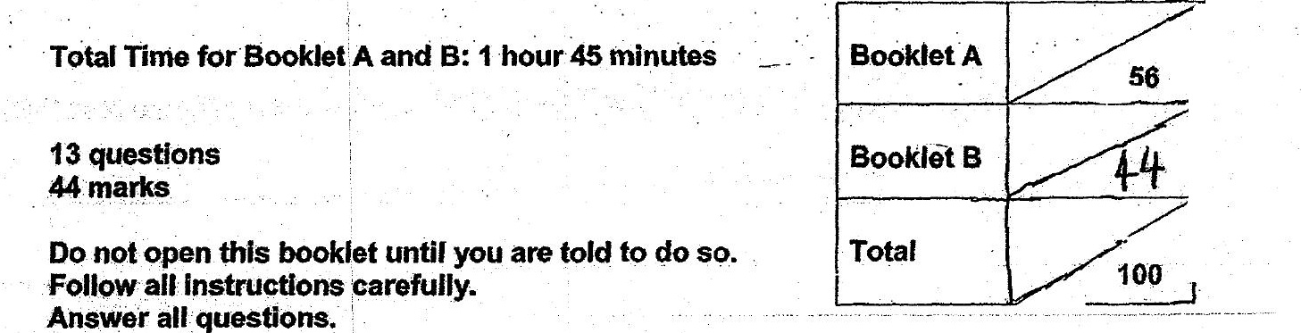

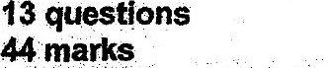

This paper consists of.15 printed pages.