For questions 29 fo 41, write your answers in this booklet. ,  
The number of marks avallable is shown in the brackets [ ] at the end of each question  
or part question... | (44 marks)

29. Mary carried out an experiment to find out whether light is. needed for  
photosynthesis. :

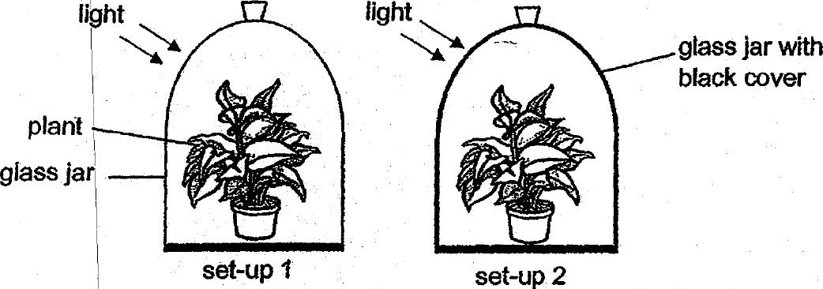

a {a) What is the purpose of set-up 17

(b) Based on her experiment, how can Mary confirm that light is needed for  
photosynthesis? : (2]