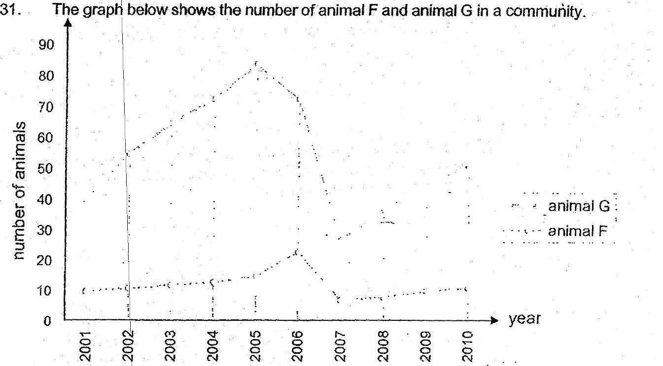



(a) Animal F and G have a prey-predator relationship. Based on the graph  
above} which animal is a prey and which is a predator? uate [1]





(5) Based pn the graph given above, there was a period with very little  
rainfall So



(c) Other than lack of water for the predator, Give another possible. reason: ad  
why with very little. rainfall would cause a decrease in the population of  
the predator. = {1]

