32. -Halim wanted.to conduct an experiment to find out. if plastic. is harmful to the  
environment. He buried a plastic box and a paper box for a month. Every week,  
Halim dug out the boxes to observe them.

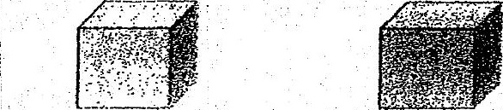

piastic box paper box

- (a) — Besides the size of the boxes, state two other varlables that he should  
keep the same in order for it to be a fair test> {1]

(b) The results of Halim’s experiment showed that the plastic box remained  
the ‘same condition while the paper box had broken down into smaller  
pieces. Which of the following statements is supported by. the results of  
Halim’s experiment? Puta tick in the box next to the correct statement.

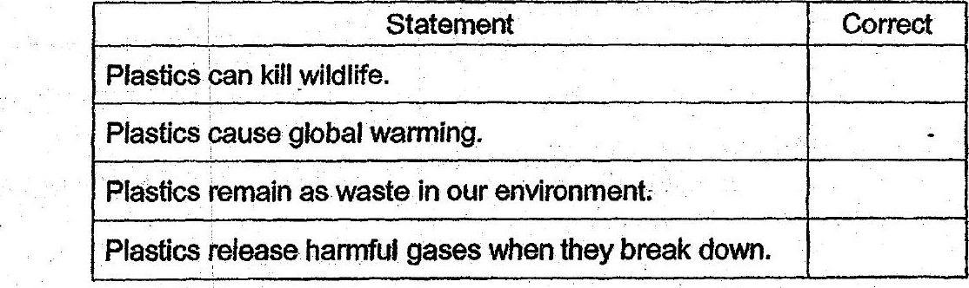

coon _- (c) State one way that we can help to reduce plastic waste in our  
. environment. a . (1]