(d). . The forest where organism B lives in is being cleared for building of new  
houses. How will this affect the population of Organism B? Explain your

34. The diagram below shows a table fan...

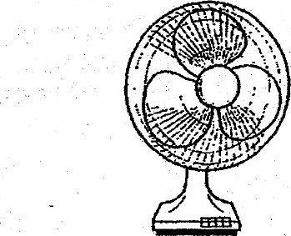

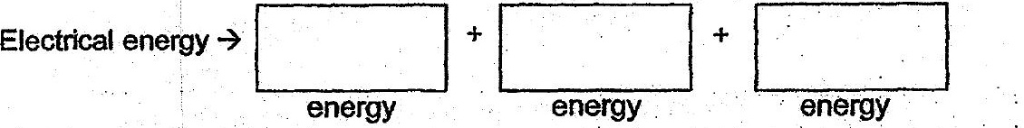

(b) | Explain why the fan continued to spin for a while even after the switch  
was-turned off. a it}