

For each question from 1 to 28, four options are given. One of them is the correct answer.  
Make your choice (1, 2, 3 or4) and shade-your answer on the Optical Answer Sheet provided.

1. The two graphs below show how the light intensity and the depth of the pond affect the  
rate of photosynthesis of the submerged water plants.

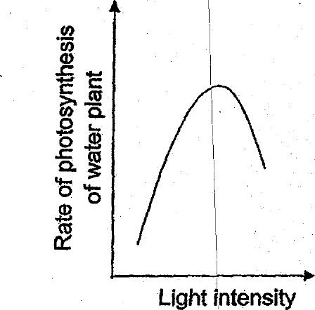

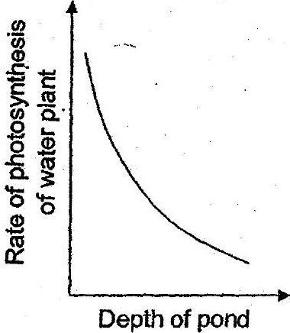

(3) Therate of photosynthesis does not depend on the depth of the pond.  
(4) The fower the depth of the pond, the higher the rate of photosynthesis.

2, Which one of the following is not a fossil fuel? -

(2) charcoal _



(4) natural gas