35. Nathan made paper flyer A with a paper clip as shown in the diagram below.

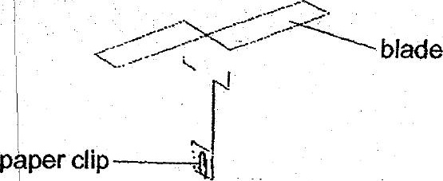



He wanted to find out if the number of paper clips’Gn paper flyer A would affect  
the time it took to fall to the ground.

(a) What must Nathan measure fo help him draw a conclusion? {1]

ov Nathan threw paper flyer A with one paper clip and measured the distance it  
, travelled. He then trimmed off 1 cm from each of the two blades of paper flyer  
= A and measured the distance it travelled when it was thrown from the same  
. height. |  
)

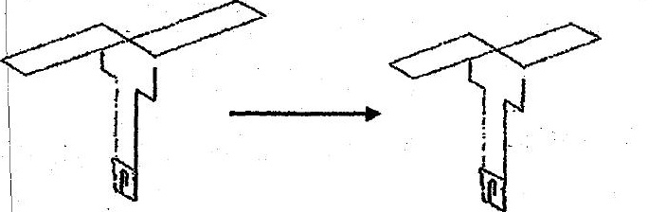

Paper tlyer A after trimming off the  
| blades

(b} — Would the distance travelled by paper flyer A be affected after the blades  
oo +. weretrimmed? Explain youranswer, © = =) RJ...

|  
(c} Name one fruit or seed with a similar structure like paper flyer A. {1}