36. Lennard used.an. open-top cardboard box and a balloon to make a toy as shown  
below. He then used it to investigate if the size of the balloon would affect the  
distance moved by the foy. ~~~





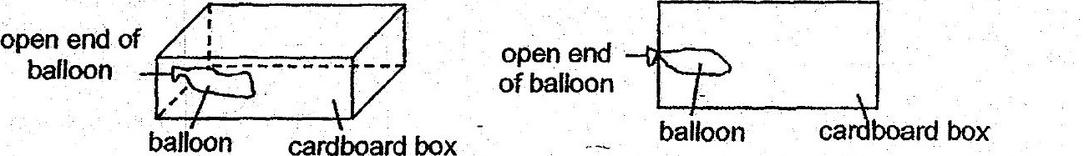

He inflated the balloon with some air before twisting the open.end of the balloon  
and holding it between his fingers. He then placed the toy on the- floor and  
released his grip on the balloon. Immediately, the toy moved a distance away  
from him. He then measured the distance moved by the toy.

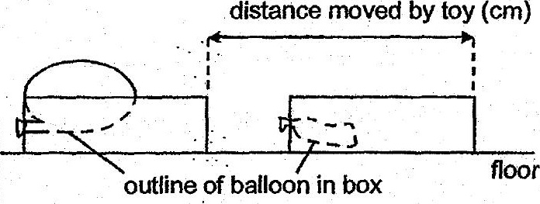

Lennard then inflated the balloon with more air and repeated the experiment.  
He noted that the toy moved:a greater distance.



