

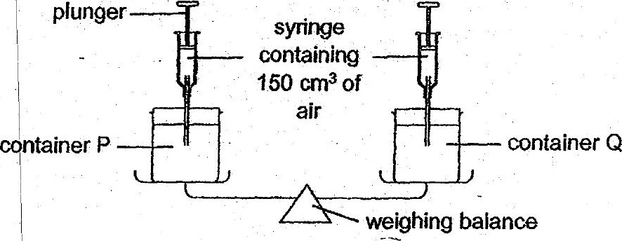

(a) aay Nour be observed when 150 cm’ of air was pumped into container  
QO? | {47

Thomas set up an experiment as shown below.

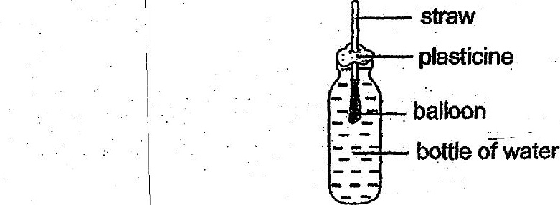

(c) Thomas tried to inflate the balloon by. blowing through the straw. Wouid  
the balloon inflate? Give a reason for.your answer. ft]