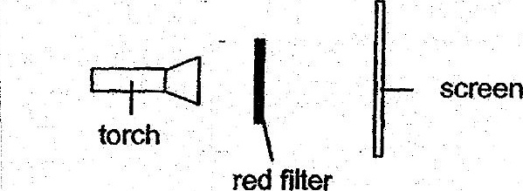



When the torch was switched on, she noted a Square patch of light on the  
screen. She then repeated the same experiment with blue and green filters.

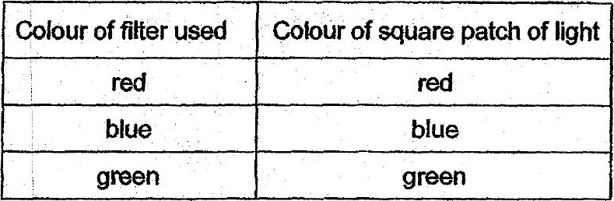

(a) § Whatwas the aim of Alishas experiment?

Alisha then placed a can of drink behind a red filer as shown in diagram 2.

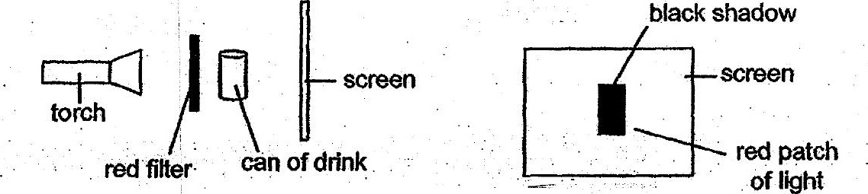

(b). .. Diagram 3. shows: what. she saw on the screen when the torch was  
switched.on. Give an explanation for Alisha’s observations in diagram 3.