39. Wen Xiong wanted fo set up.a circuit to light up a hall using two special switches.  
Switch 1 can be tured to positions A or B and switch 2 can be tumed to  
. positions Cor D.  
He set up the circuit so that the bulb will be lit as described in the table below:

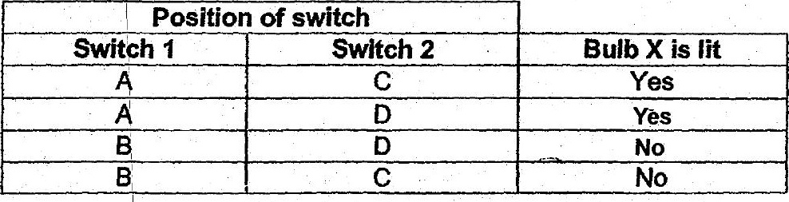

(a) The diagram below shows part of the circuit. Complete the circuit so that  
#t will work as described. {21







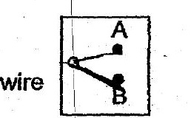

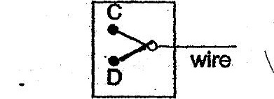

_ (b)_— fone more bulb is added to the circuit in series, how would it affect the  
re brightness of bulb xX? me (1)