40. Hussein used a water collector to collect some water while on a trip to a desert.  
He placed the water collector in an open area in the evening and collected the  
water in the morning:

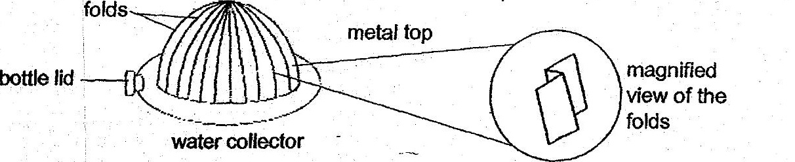

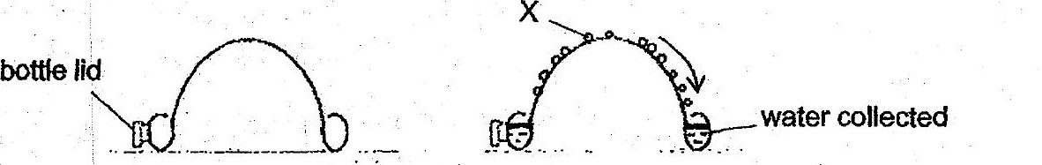

cross-section of ~ cross-section of  
| water collector ~ water collector  
: (evening) (next moming)



(b) Explain why metal is used to make the fop part of the water collector. [2]

(6) Explain why there are folds in the metal top.