41. _ The diagram below shows water heater A. The heating coil inside the tank is  
_ able to heat the water up fo a temperature of 49 °C when the heater is turned  
on. The temperature of the water.is: then maintained at 49 °C until the heater is



replace the water used.

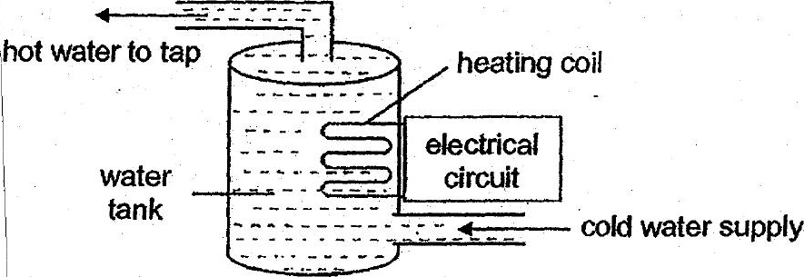



The graph below shows the temperature of the water in the tank over a period

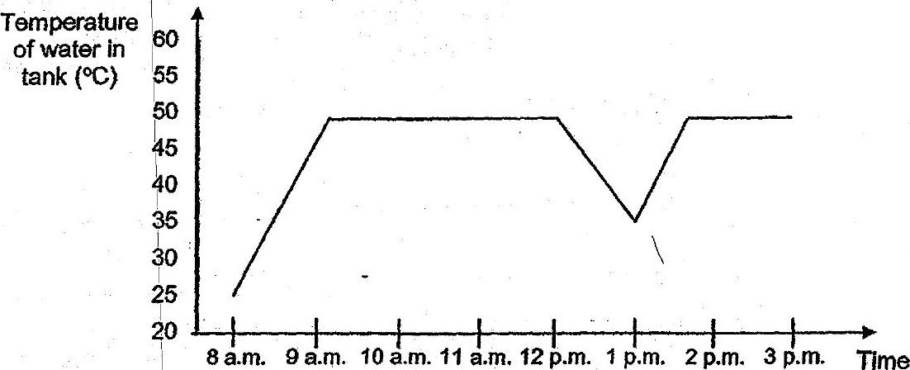



(b) Jia Ming took.a bath. during the.period shown in the graph. Based onthe  
graph above, what fime did he probably take his bath? {t]