(c} While bathing, Jia Ming noticed that the temperature of the water was  
not as hot as when he started bathing. Give a reason why this isso. [1]

The diagram below shows water heater B. This type | of water heater does not  
store water in a tank. When hot water is needed, the heater is switched.on and  
cold water passes through the heater to be warmed up before leaving the  
heater. The water heater takes about 5 minutes to heat up the water to a  
temperature of 49 °C, :

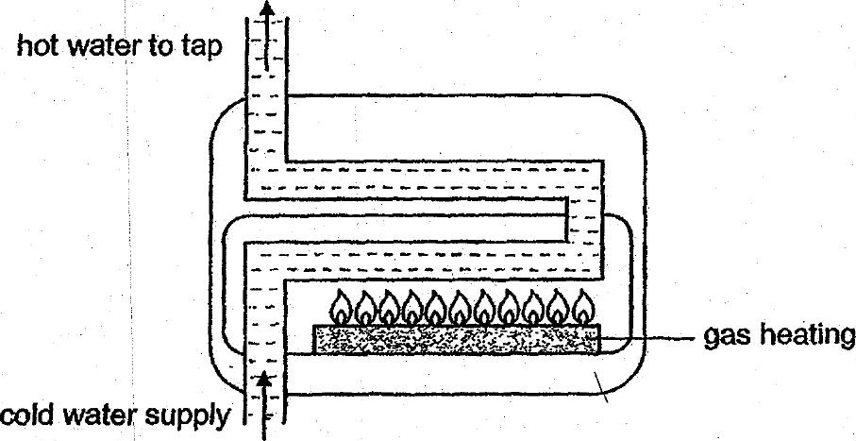

water heater B

(d) | Which water heater A or B is more energy saving? Explain your choice.  
. i : . (t}

~~ Friel of Booklet 8B ~~