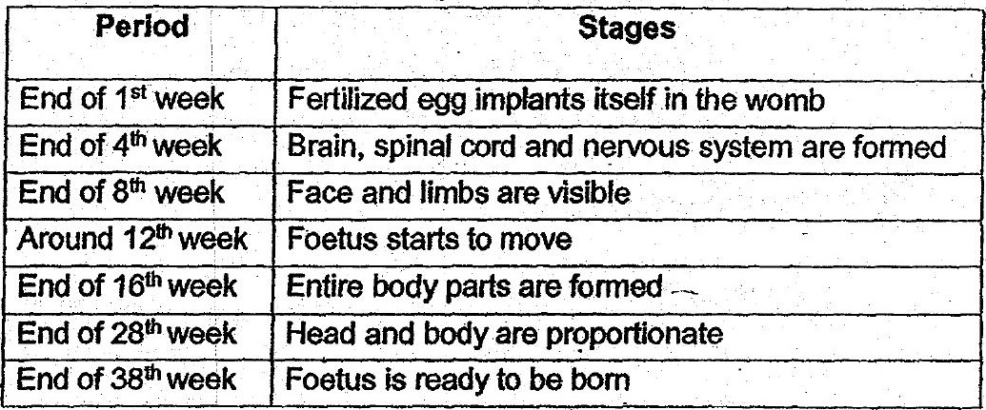

From the table above, when is the earliest time the parents are able to find out the  
gender of their baby?









4. _ Reforestation is a process of replanting an area with trees. Which of the following are  
the banefits of reforestation?

A More soil would be eroded. ©

5B More oxygen woulda be released Into the air.







