5. F, G, H, J and K are five organisms living in a community. The food relationships  
between the five organisms are stated below:

| Organism K feeds on Organism J.

¢ Organism F and J feed on Organism H.

e| Organism G feeds on Organisms F and H.

Whicn one of the following is correct’?

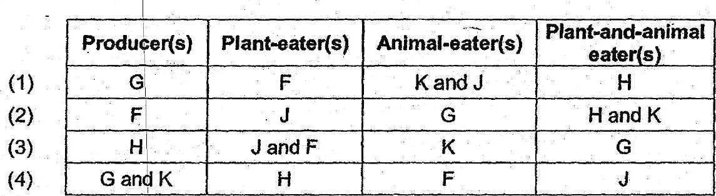

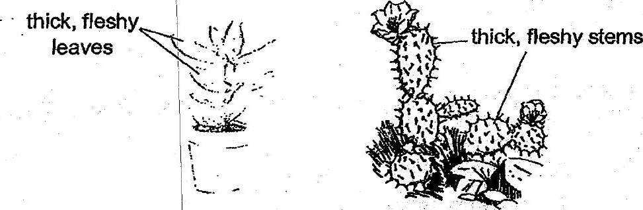

Which one of the following best explains the function of these adaptations?  
(1) Adaptationfor pollination. «5 ame



(3) | Adaptation for water retention.

(4) | Adaptation ror getting suniignt.