8. Study the food: chain shown below,



What is the main source of energy for the food chain?





(3) . Water |

(4) Carbon dioxide



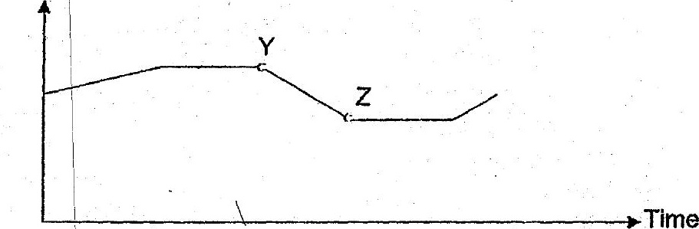

_. Which of the following explains the change in the population of bees shown by YZ in  
the graph? | .

' A» There was a drought.

B . Butterflies were introduced to the habitat. -

eG More land was used for building of hotises. ,

D A disease had infected on-some of the flowering plants.

(1) Aand Bonly  
(2). Cand D only



