10. Which one of the following adaptive features of the organisms is Incorrectly matched  
to its function? . |

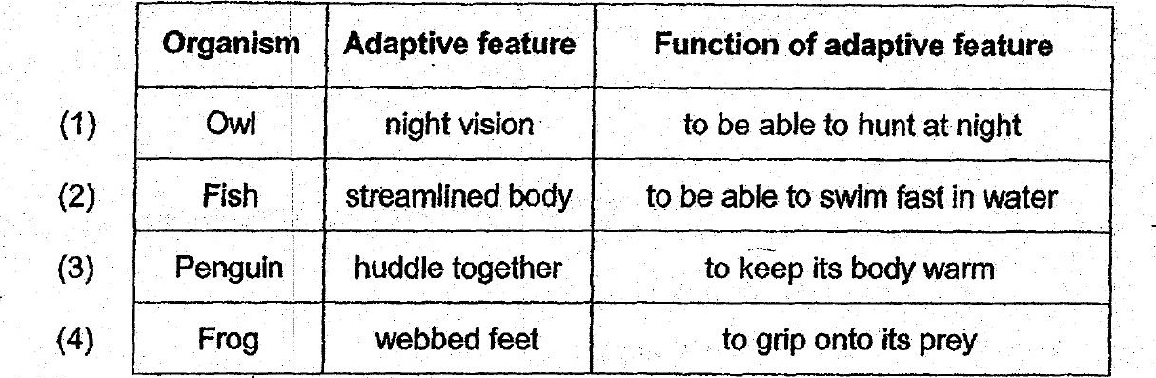

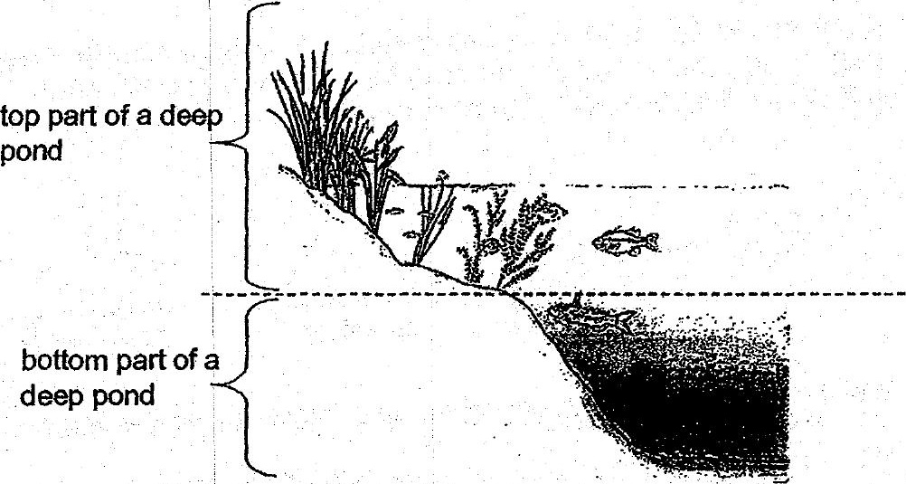

There are more aquatic plants found at the top part of the deep pond. What is the main  
reason for such an observation? . -

