12. Study the diagram below.

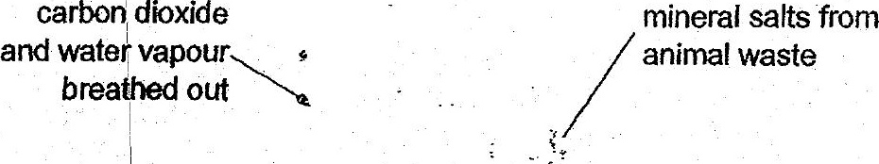







(3) Carbon dioxide and mineral salts only.

(4). Carbon dioxide, mineral salts and water.

13. Jody poured 200 mi of water into container P as shown in the diagram below. She  
then poured all the water from container P to container Q. All the water was then  
poured out from container Q to container R.

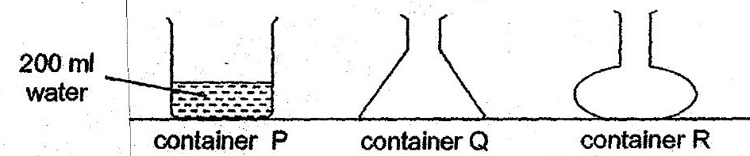

(2) ~ She was trying to find out if water has a definite shape. 7  
(3). . She was trying to find out if water has.a definite. volume.