14. The diagram detow shows three. identical beakers X, Y and Z. Three pieces of  
plasticine of different sizes were placed into the beakers. The-beakers were then filled  
to the brim with water. -

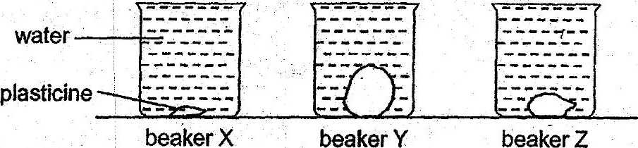

Which one of the following shows the most likely amount of water added into each  
beaker? — i

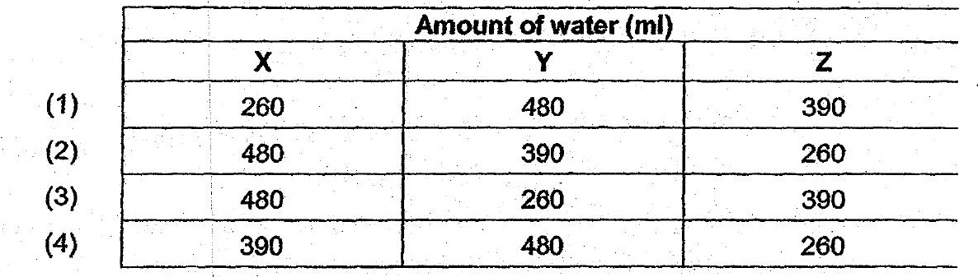

15. . Mei Ling wanted to investigate whether the size of a magnet affects the greatest  
distance. it can attract a paper clip.







-. ° .O Typeofpaperclip~ =. 6. 5 es,

= Distance between magnet and paper clip





