10, Study the food web below.

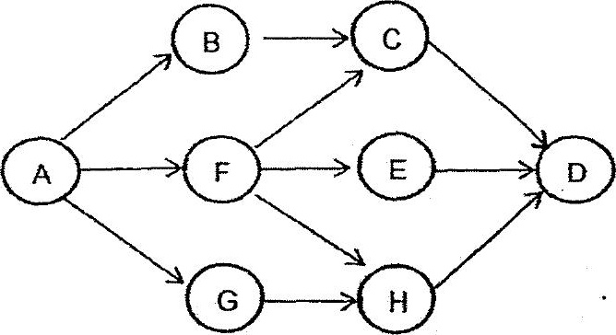

if the whoie population of organism F is killed by a disease, which of the  
following population will likely decrease in number first?