17. Jamal wanted to find out the suitable living conditions for organisms X, Y and Z. in  
‘his container, there are four equal areas, P, Q, R and S, with different conditions  
as shown below.

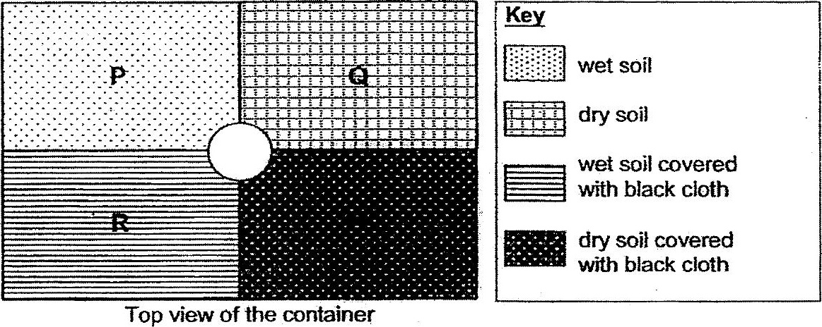

The same number of organisms, X, Y and 2, were placed in the dish in the centre  
of the container at the beginning of the experiment. At the end of the experiment,  
the total number of organisms in each area was counted and recorded in a bar  
chart below.

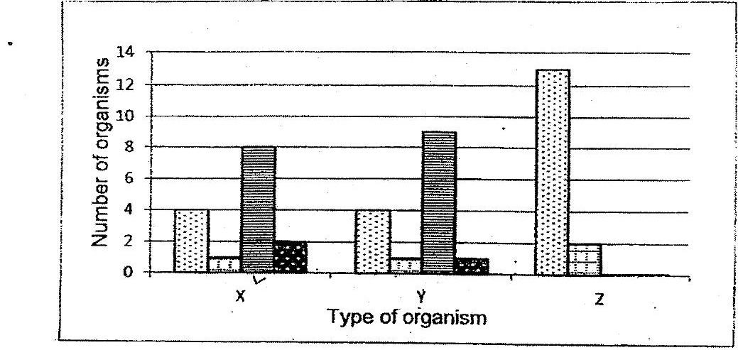

Which of the following statements are tne?

A: Only organism Y can be found in the leaf litter habitat.  
  
B: Organism Z prefers an environment that is bright and wet.-  
  
C: Both organisms X and Y survive best in an environment that is damp and  
dark.

(1) Aand B only  
(2) Aand C only  
(3) Band C only  
(45 A, BandcC