12. . Study the-two graphs below. They show the amount of carbon dioxide present in  
the air in two towns, X and Y, over a period of time.

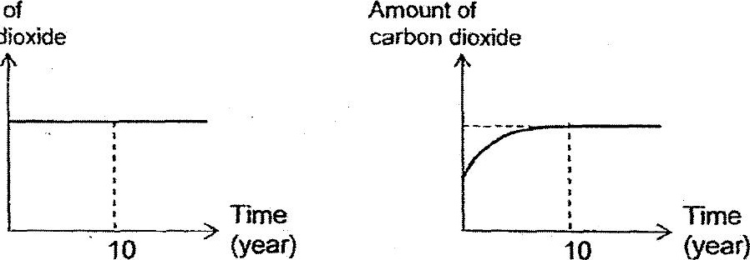

Amount of  
carbon dioxide



A: The air in town Y Is less polluted than town X after year 10.  
RB: There could be a decrease in the number of factories in town Y in the first

C: There could be deforestation in town Y in the first 10 years.

(4) Aand dB only  
(2) Cand Donly  
(3) A, Band C only  
(4) B, C and D only