14, Alice removed an outer ring of a stem from a potted piant as shown below.  
As a result, the tubes carrying food and water were removed. She covered  
leaf X partially with black paper on both sides. She watered the plant  
regularly and placed it under the sun.

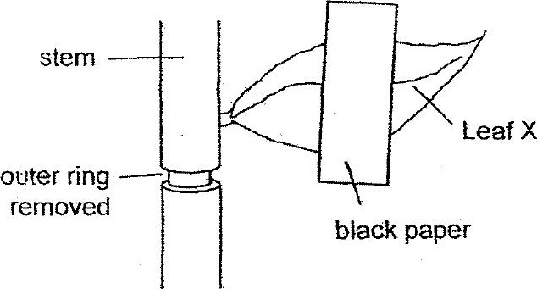

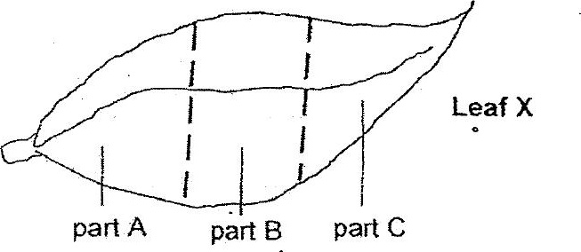

VWhich part(s) of the leaf would the iodine solution remains yellowish  
hrown?

(i) Aonly  
  
(2) Bonly  
  
(3) AandC only  
(4) A, Bandc