15. Siew Lee has four different materials, A, B, C and D, that have been cut to the  
° game size and shape. They have a mass of 2g each at the start of the  
experiment.

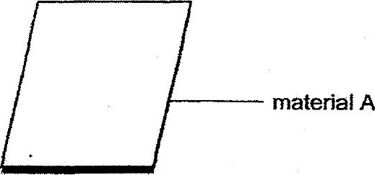

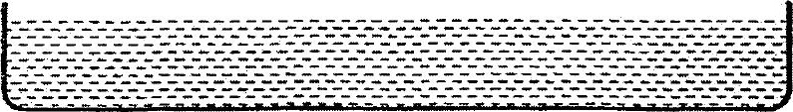

econtamer with water

She dipped material A in the container of water for 10 minutes and meabured  
its mass after that. She repeated the experiment with materials B, C and D and  
recorded her observations in the table shown below.

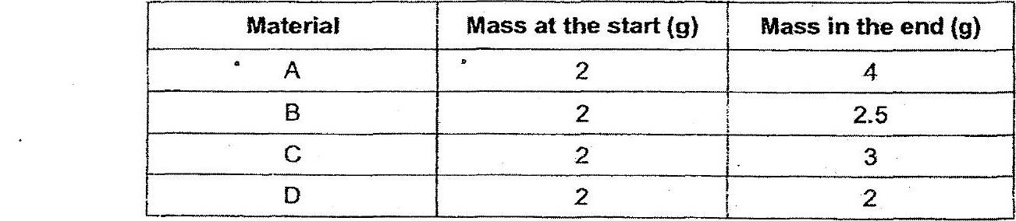

Basec on ihe above results, which material will be the most suitable for Siew  
Eee to make a hand towel?