16. Mr Tan ined to pull two different boxes over the same distance as Shown  
below.

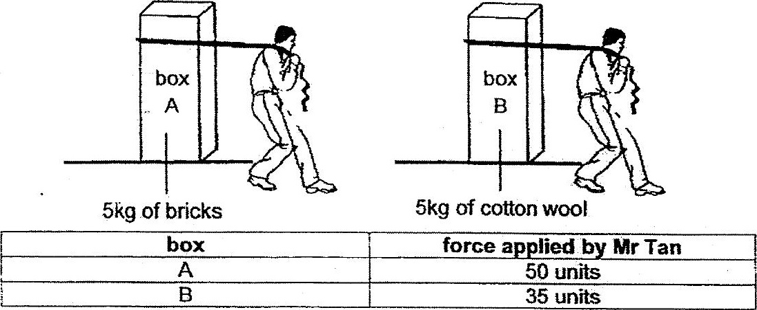

Which of the following correctly explains why Mr Tan had to. use more force to  
pull box A?

(1) Box A has more volume ihdn box B.  
  
(2) Bricks are heavier than cotton wool.  
  
(3) The base of box A is rougher than box B.  
  
(4) The cotton wool hes air spaces while the bricks do not.

