18. Three containers were filled with the same amount of water and placed ona  
table in the same room.

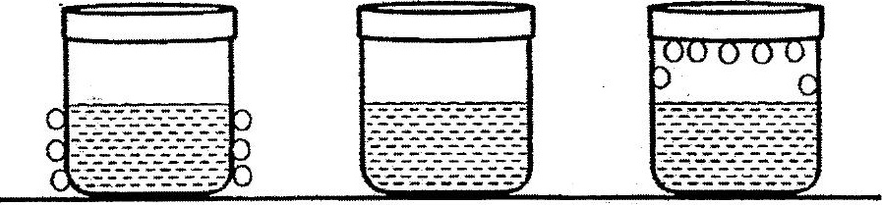

At the end of ten minutes, water droplets could be seen on ihe containers as  
chown above.

What is the possible temperature of the room?

"49. Three studenis made the following siatements.

Danny <: Only metals are conducior of electricity.  
  
Fiaine : We should handle electrical appliances only with dry hands.  
  
Frank =: Aclosed electrical circuit musi comprise a bulb, wires and a  
switch.

V¥hich of the students is/are correct?

(1) Elaine only  
(2) Frank only  
(3) Danny and Elaine only  
(4) Danny and Frank only