20. James made a circult card as Snown in igure 1. He connected an electrica:  
circuit as shown in figure 2 to figure 1.

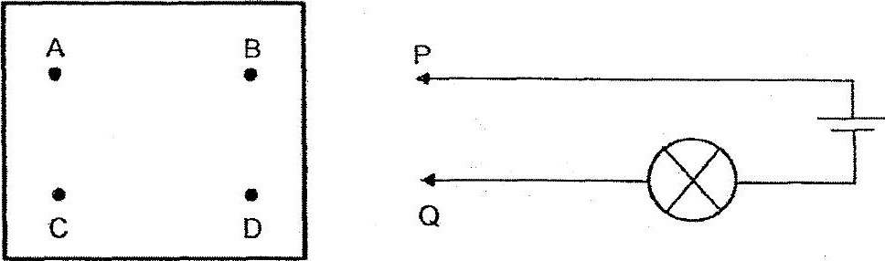

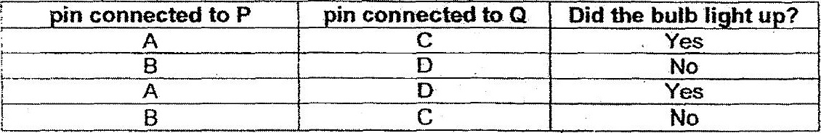

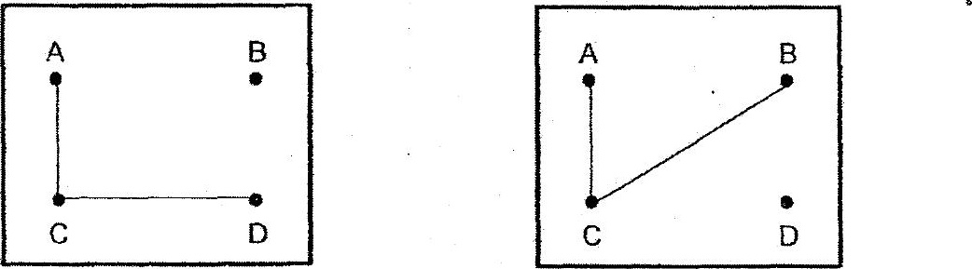

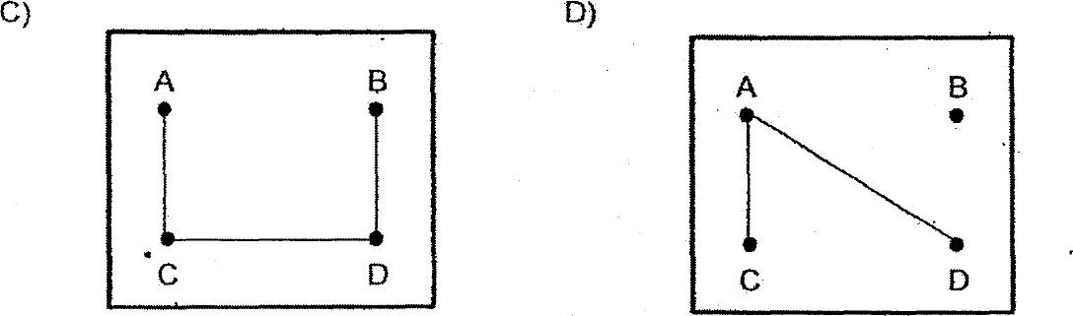

(1) Aonly  
(2) Bonly  
(3) AandC only  
(4) Aand D only