23, Rashid hung four bails, A, B, C and D, which are made of different materials. Al  
four balls were released from the holder at the same time and the depressions  
made in a basin of soft dough were measured.

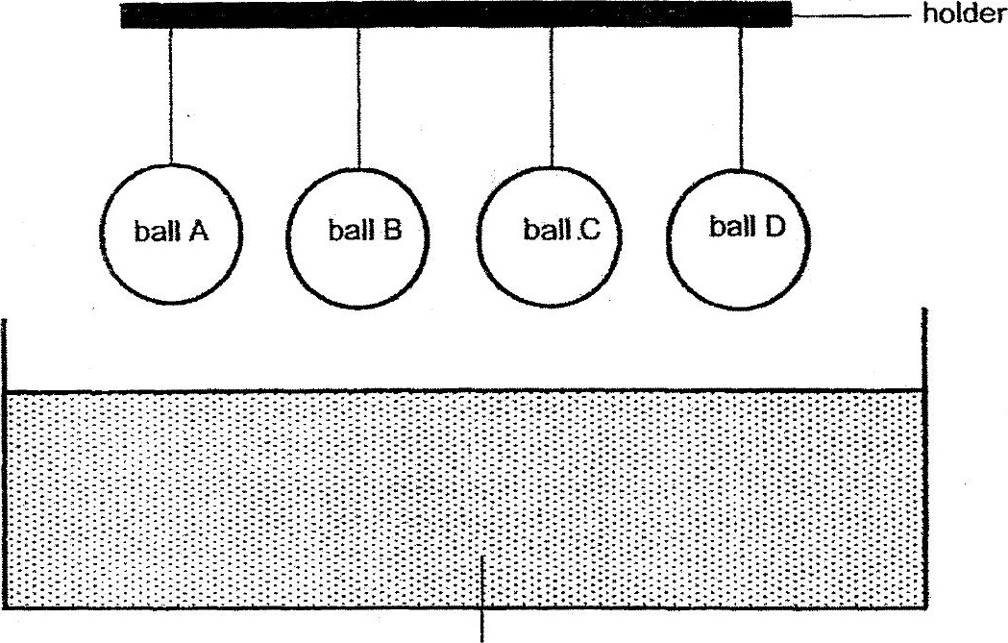

basin of soft dough



Which of the following shows the correct arrangement of the balls from the  
lightest to the heaviest?

(1) O,C,A, B  
(2) BLA C,D  
(3) C,A,B.D  
(4) ABDC