24. Ali conducted an experiment to find out how the size of the sail affects the  
distance moved by the sailboat. The table below shows the size of the sails  
used. The same amount of wind was present for ail the experiments.

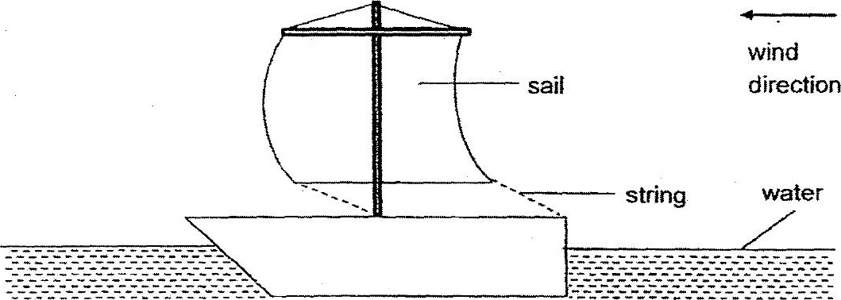

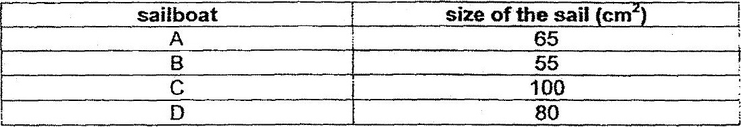

(2) Distance

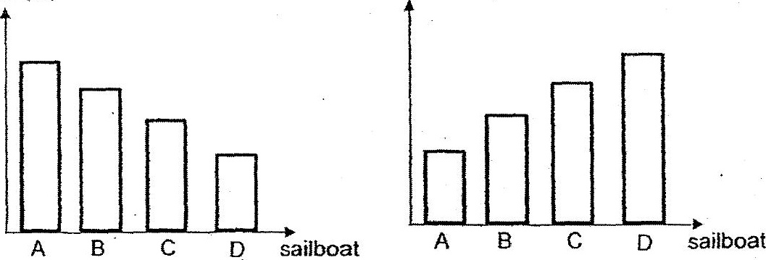

(4) Distance

(3) Distance

