25. Caleb created the set-up shown below. The buzzer will sound each time he  
closes the switch.

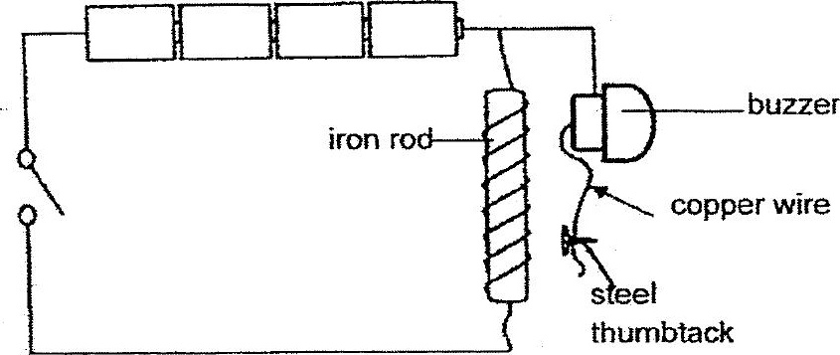

After changing the set-up, Caleb noticed thai ine buzzer did not sound when  
the switch was closed. What change(s) did he make?

A: Add one more battery without changing the rest of the set-up.  
  
B: Coil more turns of wire around the iren rod without changing the rest of  
the set-up.  
  
C: Change the steel thumbtack to a copper thumbtack.

(1} CGonly  
  
(2) AandB only  
(3) Band only  
(4) A, Bandc