26. Ravi plays basketball during his free time and he observed the height the ball  
bounces back each time after it hits the ground.

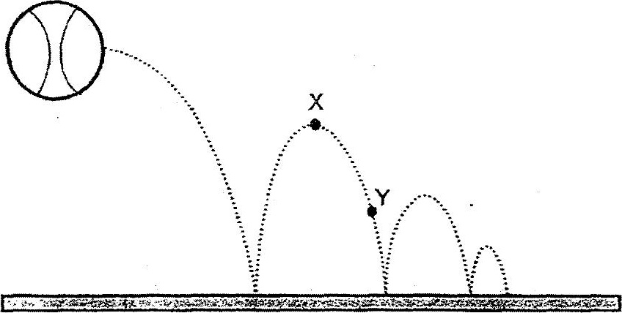



A: There is more gravitational force acting on the ball at position X than at  
position Y.

B: fhe amount of gravitational potential energy on ine ball is the same at  
both positions X and Y.

C: From position X to YY, the gravitationai “potential energy of the ball  
decreases but the kinetic energy increases.

D: From position X to Y, the gravitational potential energy of the ball  
increases but kinetic energy decreases.

Which of the above statements ts/are true?

(1) Aonly  
  
(2) Conly  
  
(3) Band Donly  
(4). A, BandC only