27. Study the hydroelectric power station shown below.

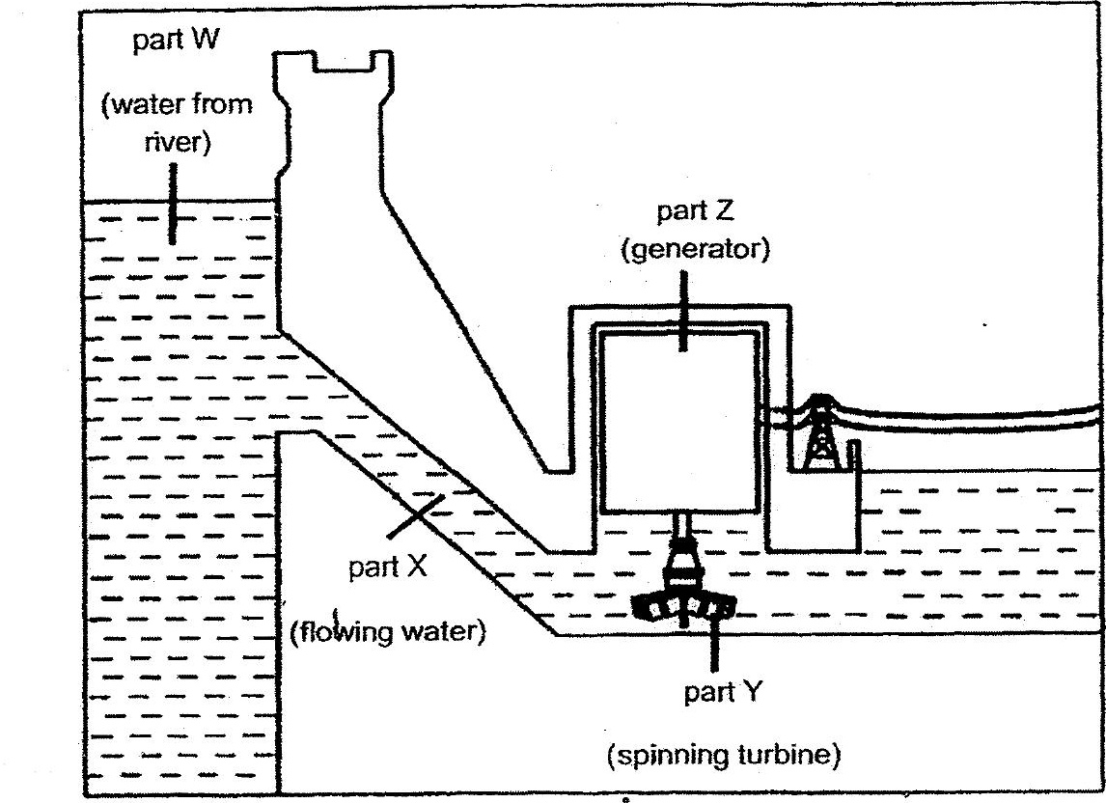

Which of the following shows the correct main energy conversion from paris W  
to part 7? .



energy of the energy of the energy of the energy of the  
river water at flowing water spinning turbine generator at  
part W at part X _at part Y part Z

