

Answer ail the questions in the spaces provided.

29. Study the classification chart below.

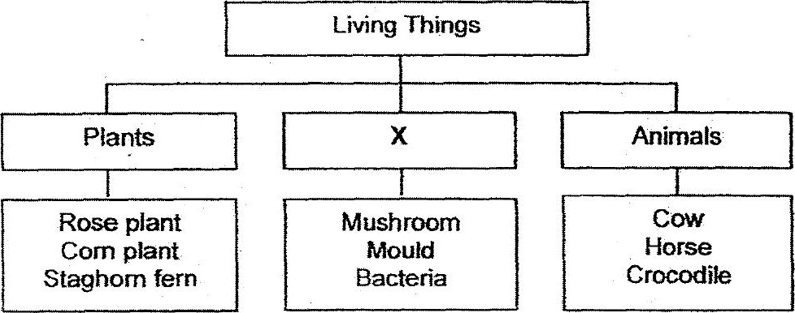

(a) Winte a suitable heading for group X. (im)

: (b) The animals produce waste in the form of droppings. State the process that  
breaks down the droppings into simpler substances that is useful for plants  
to grow better. (tm)

(c) Based on your answer in (b}, state now the simpler substances heip the  
plants to grow better. (1m)

(d) If group X contains only mushroom and niould, what is a suitable heading”  
for this new group? (im)

