30. ‘Simply Fresh’ is a soluble substance that helps to keep flowers fresh for a  
longer time. Mrs Tan wanted to investigate if this is true. She used two  
similar vases, X and Y, for her experiment.

The items in vase X are shown mn the table beiow. She also.created a control  
set-up using vase Y.

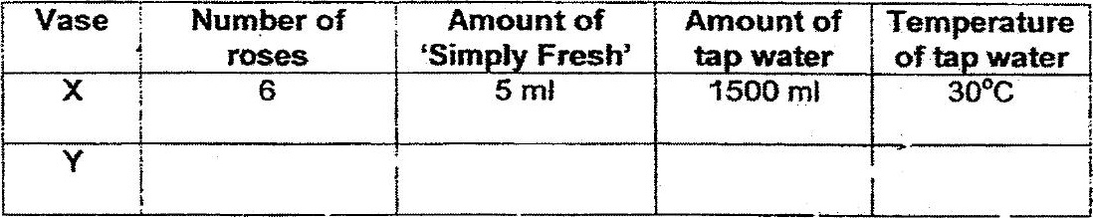

(b} State one other important vanabie Mrs Jan must keep the same during the  
experiment to ensure a fair test. (1m)

