31. Muthu leamed in school that there are more stomata found on the lower  
surface of leaves. He then set up an experiment using four similar potted  
plants, A, B, C and D, as shown below. He applied oil on different parts of  
their leaves. All four plants were placed side-by-side under light and watered  
with equal amounts of water daily.

‘of all leaves of all reaves all leaves.  
eB ep iD Isp  
, \ ho  
Ld Ld Ld Co  
A B Cc D

(a) Arrange the order in which the ptants above woutd die, starting with the piant  
that takes the shortest time to the one that takes the longest time. (1m)

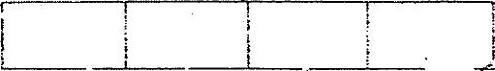

(6) Muthu took another plant and tied a clear plastic bag around it as shown .  
below. He did not apply any oil to the leaves. The plant was provided with  
sufficient light and water.

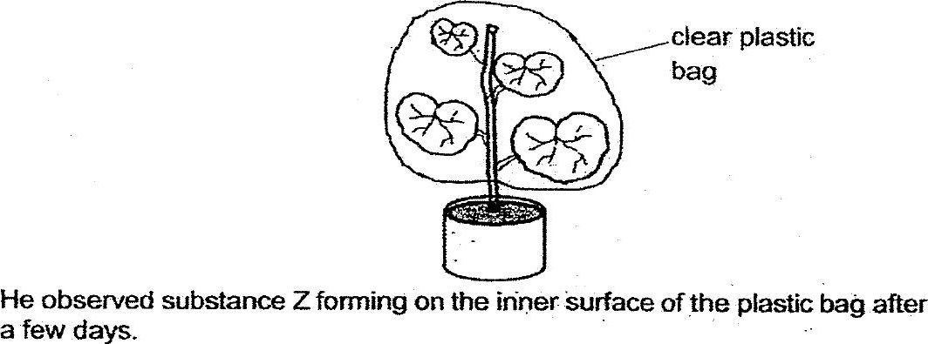



(Hi) Explain how substance Z was formed. (2m)

