32. Study the food wep shown.

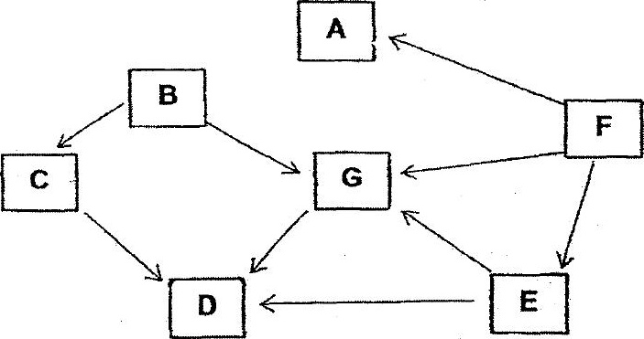

(a) Based on the food web, fill in the table below with tne appropniate ietters, 5,  
C, D. E, F and G. Do not use letter A. (2m)

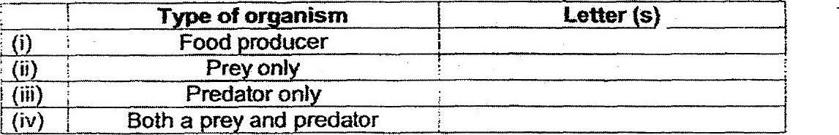

(BD) Using the folowing information, draw two arrows to add organism fH in ihe  
food web above. (im)

(i) Organism H is a plant ano. animai eater.  
  
(ii) | When the population of organism H increases, the population of  
organism B decreases.  
  
(i) When the population of organism H. decreases, the population of  
organism A increases. —

