33. The tabie below shows how some. animals adapt to survive in their  
habitais.

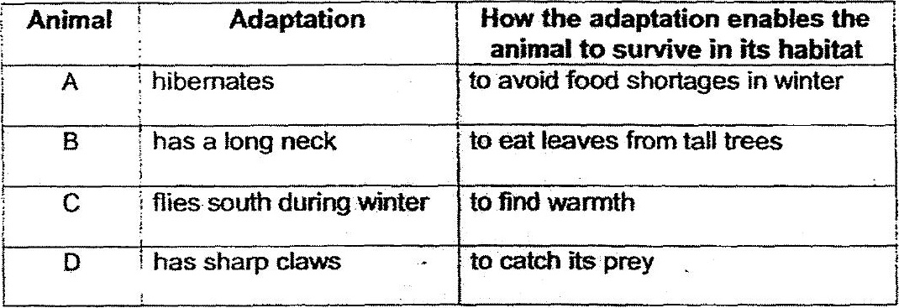

(a) Based on the information above, classny the animals given using the flow  
chart below. Write letters, A, B, C and D in the correct boxes, using each  
letter once. (2m)

