34. Natasha wanted to find out if the rate of photosynthesis of elodea would be  
affected by the intensity of light. She put the same type of plant into three giass  
containers and placed each of them at different distances from three similar  
table lamps in a dark room for an hour.

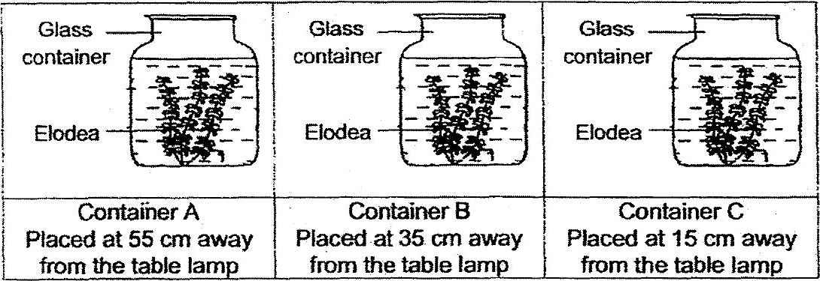

She recorded the number of bubbles produced at 5 minutes interval for one  
hour and plotted the graph below to show the results in container B.

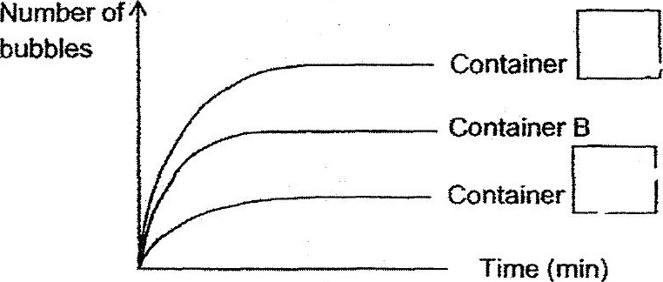

(a) Using the same graph above, iabel the graph to show the results of the  
experiment in containers A and C respectively. {1m)

(5) Natasha added a few guppies into container B. She placed the container at 35  
cm away from the table lamp as she had done previously and repeated the  
experiment again.

she observed that the number of bubbles produced by the elodea was more.  
Explain her observation. (2m)

