35. Mr Tan drew his farnily tree as shown Delow.

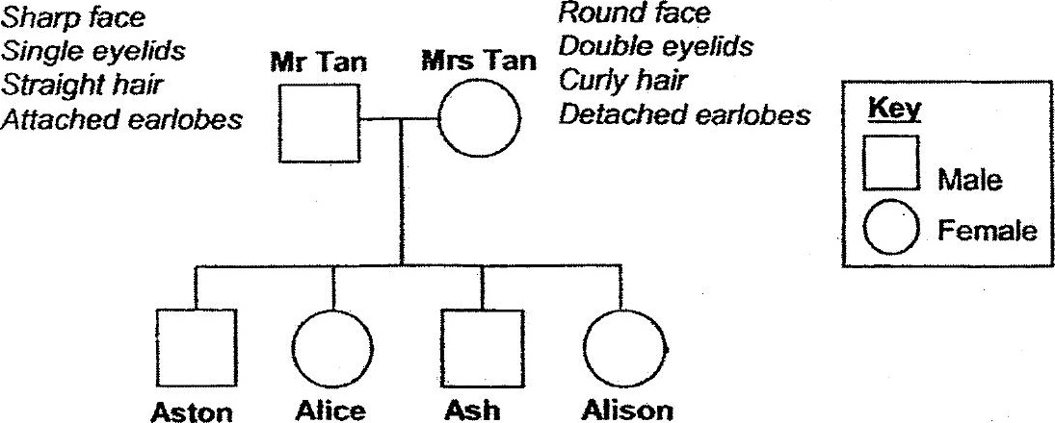

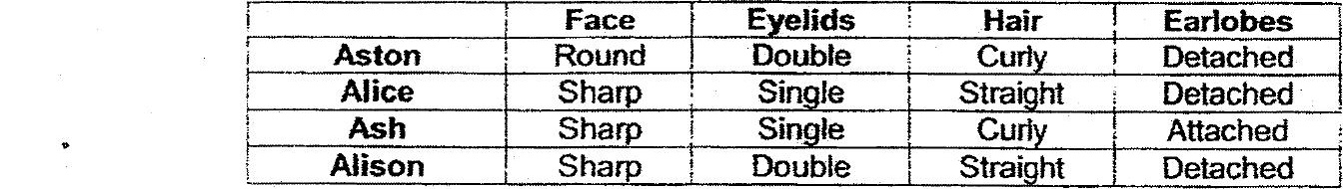

(a} Based on the information above, what are the common characteristics Alice  
and Alison have inherited from their father? (1m)

(Db) Alison Is married and she has a young son. Draw. lines and symbols to  
represent her husband and son in the family tree. (1m) / :

