36. Study the set-up shown Delow.

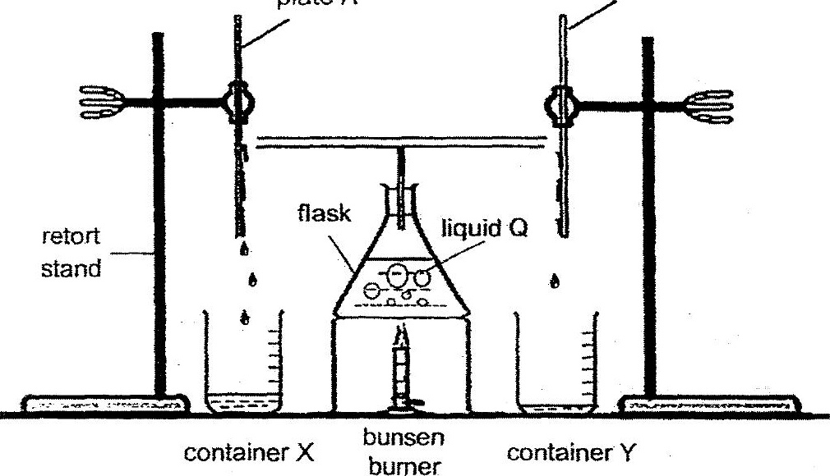

After the bunsen durner was i up, some liquid was seen to be collected in  
both containers X and Y.

{a} Plates A and 6 are made of diferent materiais. Explain the difference in the  
amount of liquid collected for container X. (4m).

(b) Liquid Q is blue in colour as blue dye powder was added to it. However, the  
liquid collected in container X was colourless. Explain why. (1m)

