

For Questions 1 to 28, choose the most suitable answer and shade its number in  
the OAS provided.

1. The table below shows information on four pianis, W, X, Y and Z, based on  
two characteristics. A tick (V) shows that the plant has the characteristics.

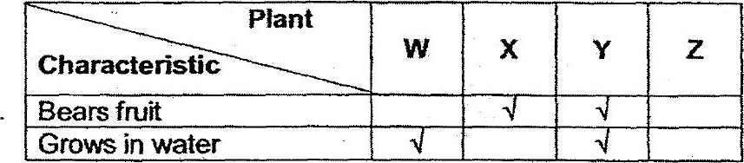

From the information above, where do plants W, X%, Y and Z, belong to in  
the following classification chart? :

