37. Andy has a solid that is made up of substances A and B as shown  
below.

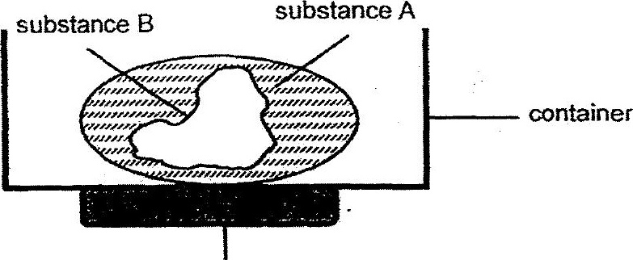

Substance A has a much lower melting point than substance B. Andy  
would like to make object X using only substance A as shown below.

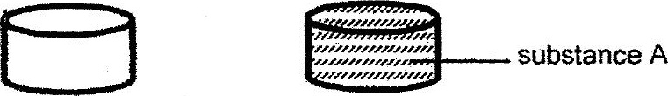



Explain how he could create object X using the empty. container and the  
set-up shown above. (2m)

