38. Raja created the following set-up. He wanted to find out how the different  
table surfaces affects the distance moved by the box on the table.

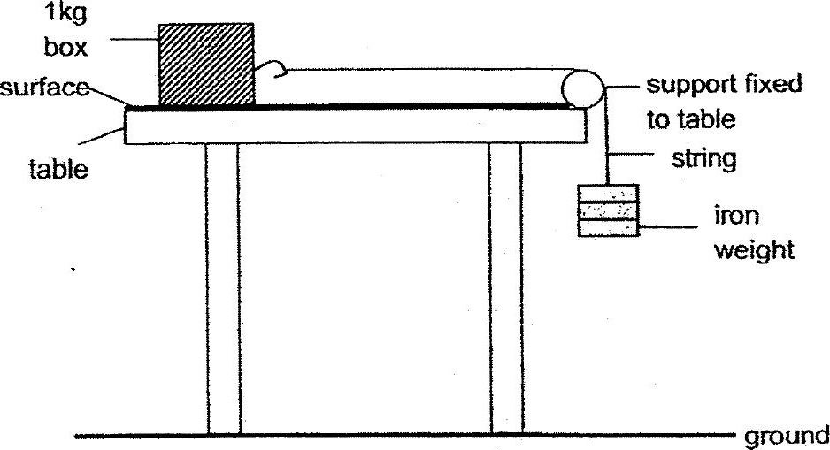

He repeated the experiment with two other surfaces and the same amount  
of iron weights. He recorded the distance moved by the box on the table as  
follows.

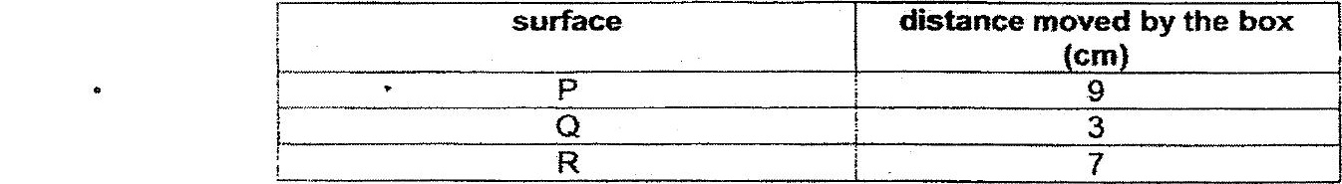

(a) Tick(v) the correct columns in the table below in order for the experiment to  
be a fair test. (im)

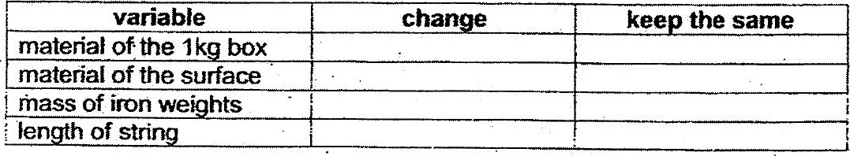

(b) Which surface, P, Q or R, is best used to make the soles of shoes? Explain  
your answer. (im)

